Virginia States University
Department of Engineering and Computer Science
ENGR 101-02 – Introduction to Engineering (Fall 2020)

Date:
Test #: 1 (Chapters 4 and 5) Section 2

On my honor, I have neither given nor received any unauthorized aid on this test, and I pledge that I am in compliance with the VSU Honor System.

Print Name Signature

Section 2: Read each question carefully and show your work to get full credit.
- Determine the magnitude and direction of the resultant force by adding the rectangular component of each force (that is by resolving the force their x and y components). (10 points)
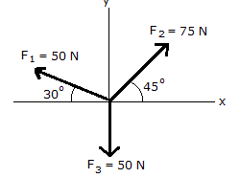

- Consider the three forces, F₁ = 5 i + 2 j kN, F₂ = −3 i − 8 j kN and F₃ = −4 i + 7 j kN. Find the resultant force, its magnitude, and direction with respect to the positive x-axis. (5 points)

- A 30-cm diameter solid steel sphere hangs from cables as shown below. Find the tension in cables AB and AC. For the density of steel, use ρ = 7270 kg/m³. Use the “General Analysis Procedure” to present your solution. The general analysis procedure is the 7 step method engineers use to solve problems in a logical and systematic matter. (10 points)

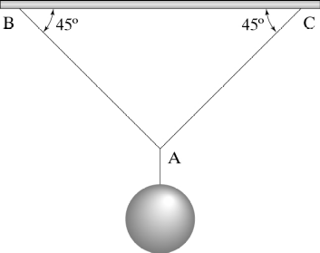

- Two cables, AB and AC has cross sectional diameters of 0.004 m and 0.006 m and tensions 2338 N and 3052 N, respectively. What is the normal stress in each cable? (5 points)

- A typical stress-strain diagram is shown below. Use the following words or phrase to identify the labelled regions: (5 points)

Yield stress Elastic limit fracture
Compressive stress proportional limit Ultimate stress
Shear stress tensile strain proportional limit

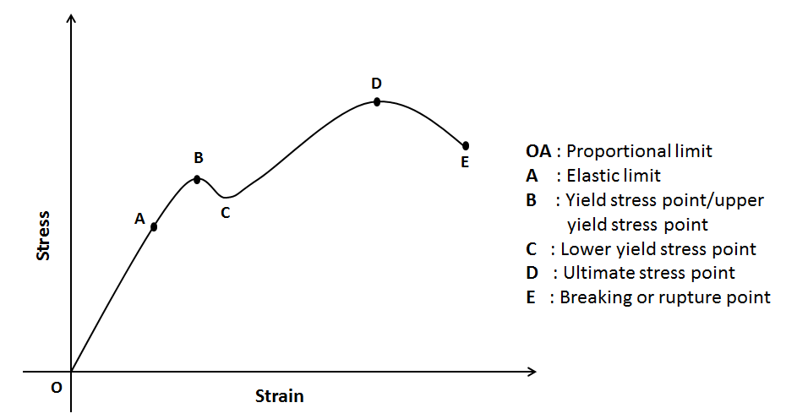

- What is the normal deformation in the cables from the previous question (question 18), if the length of each cable is 0.7 m and the modulus of elasticity, E is 200 GPa? ($Hint*1 \frac{N}{m^{2}}=1 Pa and 1 kPa=1000 Pa$) (5 points)

- A circuit element absorbs 6 W of power due to the passage of a steady current of 250 mA. What is the voltage across the element? (5 points)

- Calculate the current I₃ in the following circuit where I_{1,} I_{2,} I₄ and I₅ are 15 A, 12A, 3A and 7A respectively. (5 points)
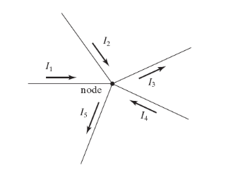

- Four resistors are connected in parallel across a 200-mA independent current source as shown below. What is the voltage across the resistors and the current in each resistor? (10 points)
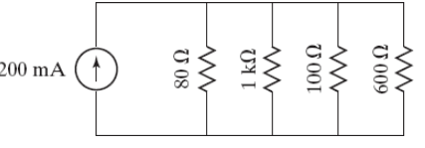

- For the DC circuit shown in the accompanying figure, find the voltage across each resistor and the current through each resistor. (15 points)

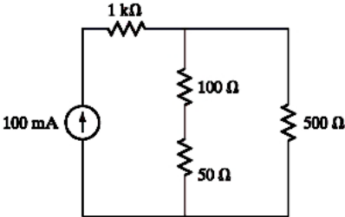

Useful Equations
- Sine Rule
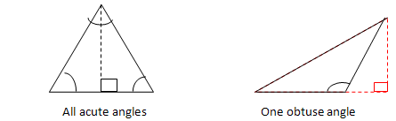
The Sine Rule is used in the following cases:
CASE 1: Given two angles and one side (AAS or ASA)
CASE 2: Given two sides and a non-included angle (SSA)
The Sine Rule states that the sides of a triangle are proportional to the sines of the opposite angles. In symbols,
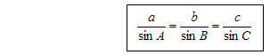

- Cosine Rule (The Law of Cosine)

The Cosine Rule is used in the following cases:
- Given two sides and an included angle (SAS)
2. Given three sides (SSS)
The Cosine Rule states that the square of the length of any side of a triangle equals the sum of the squares of the length of the other sides minus twice their product multiplied by the cosine of their included angle. In symbols:
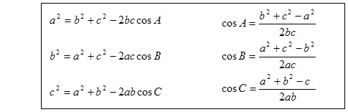
- Vector Components:
  - $A_{x}=A cosα$
$A_{y}=A sin α$
$B_{x}=B cosβ$
$B_{y}=B sin β$
  - Writing the vector components $A_{x} and A_{y}$ in terms of a scalar and a unit vector as: $A_{x}=A_{x}i$ and $A_{y}=A_{y}j$. Thus, vectors A is expressed as:
$$A=A_{x}i+A_{y}j$$
And vector B is expressed as:
$$B=B_{x}i+B_{y}j$$
The resultant of A and B is:

$$R=A+B=\left(A_{x}+B_{x}\right)i+(\left(A_{y}+B_{y}\right)j$$
The rectangular components of the resultant vector R are given as:
$$R_{x}=A_{x}+B_{x}$$
and
$$R_{y}=A_{y}+B_{y}$$
Hence we can write the result of the vectors A and B as:
$$R=R_{x}i+R_{y}j$$

The magnitude of the result vector is:
$$R=\sqrt{R_{x}^{2}+R_{y}^{2}}$$

The direction of the resultant vector is the value of the angle $θ$:
$$Tan θ= \frac{R_{y}}{R_{x}}$$

- $\sum{F}=0 (the equation for equilibrium$
- $σ=\frac{P}{A}$ Where σ is normal stress, P is internal force and A is the cross-sectional area
- $ε= \frac{δ}{L}$ Where ε: normal strain, δ : normal deformation and L: original length
- $δ=\frac{PL}{AE}$ Where E is the modulus of elasticity; the other variables are already defined.
- $Area of circle= πr^{2}$
- $I= \frac{q}{t}$
- $1\acute{e}={1.602×10}^{-19 }C$
- $V=\frac{W}{q}$
- $V=IR$
- $P=IV=I^{2}R=\frac{V^{2}}{R}$
- $R_{s}=R_{1}+R_{2}+R_{3}+$………..
- $\frac{1}{R_{p}}=\frac{1}{R_{1}}+\frac{1}{R_{2}}+\frac{1}{R_{3}}+$………..
- $\sum{I_{in}}=0=I_{2}+I_{2}+I_{3}+I_{4}+I_{5}$
- $\sum{I_{in}}=0$
- $\sum{V}=0$

